**Supplemental Materials**

**Chronic wasting disease (CWD) knowledge, risk perception, and management acceptability by deer hunters are influenced by channel engagement and state wildlife agency trust in Massachusetts**

Margaret C. McEachran1,**~~3~~, Brian M. Hoven1,2*, Martin J. R. Feehan4,5, Graziella V. DiRenzo6,1

*1 Department of Environmental Conservation, University of Massachusetts, Amherst, MA 01003, USA*

*2 Department of Biology, The State University of New York at Geneseo, Geneseo, NY 14454, USA*

*4 Massachusetts Div. of Fisheries & Wildlife, Westborough, MA 01581, USA*

*5 Department of Natural Resources and the Environment, Cornell University, Ithaca, NY 14853, USA*

*6 U. S. Geological Survey, Massachusetts Cooperative Fish and Wildlife Research Unit, University of Massachusetts, Amherst, MA 01003, USA*

*\* Correspondence: Brian M. Hoven, Email:* [*bhoven@geneseo.edu*](mailto:bhoven@geneseo.edu)

*\*\* Work was performed while serving as a Visiting Scientist with the U.S. Geological Survey, Eastern Ecological Science Center, Laurel, MD 20708*

*Any use of trade, firm, or product names is for descriptive purposes only and does not imply endorsement by the U.S. Government.*

**Description of Nonresponse Bias Check Methodology**

Specifically, we examined if there were differences in the proportion of hunters in the population with email by age binned by decade (e.g., 18 – 29, 30 – 39, 40 – 49, etc.) . This was done by setting up using a contingency table with age binned by decade (e.g., 18 – 29, 30 – 39, 40 – 49, etc.). To examine pairwise differences in proportion of hunters with email by age, we used pairwise chi-squared tests using a Bonferroni p-adjustment for multiple comparisons. The chi-squared test showed a lack of independence between having an email and age category (X2 = 7870.3, df=6, p < 2.2e-16). Similarly, we investigated if there was a difference in having an email by sex and found that there is not a significant relationship between sex and having an email (X2 = 3.8127 df=3, p = 0.28). We also found that the rate at which respondents completed the survey did not differ significantly and therefore there was no relationship between gender and retention in our final sample across gender (X2, df=1, p = 0.97). We did find a significant relationship between gender and overall survey response rates (completed or uncompleted), with men significantly more likely to respond to the survey (30% of men vs 22% of women; X2 = 29.974, df=1, p < 4.379e-08). Finally, we also assessed differences in response rate (responded at all/invited) and retention rate (completed response/started a response) by age category and found that younger people were significantly less likely to respond (15%) than older people (33%; X2= 1638.6, df= 6, p < 2.2e-16). Based on these results, we weighted models by non-response age and sex weights (= expected proportion / observed proportion). Similarly, we investigated if there was a difference in having an email by sex using chi-squared tests. Next, we examined if there was a significant relationship between sex and the following two variables using chi-squared tests: overall survey response rates (completed or uncompleted), and retention (completed response/started a response) in our final sample. Finally, we also assessed differences in response rate (responded at all/invited) and retention rate by age category. Bonferroni p-adjustment for multiple comparisons were applied were applicable.

Table S1. Beta coefficients for the linear regression model where channel usage is the response variable. We include the mean as well as the lower and upper 95% confidence interval for each variable and level in the model.

|  |  |  |  |
| --- | --- | --- | --- |
| Explanatory variable and level | Mean | Lower | Upper |
| (Intercept) | 1.5163 | 1.3944 | 1.63828 |
| Channel - facebook | -0.174 | -0.317 | -0.031 |
| Channel - instagram | -0.42 | -0.558 | -0.2823 |
| Channel - podcasts | -0.474 | -0.608 | -0.3401 |
| Channel - printed_material | 0.2315 | 0.0962 | 0.36677 |
| Channel - reddit | -0.473 | -0.586 | -0.3603 |
| Channel - state_hunting_fishing_guide | 0.3964 | 0.2628 | 0.52987 |
| Channel - tv_streaming | -0.003 | -0.141 | 0.13546 |
| Channel - ticktok | -0.382 | -0.523 | -0.2416 |
| Channel - twitter | -0.426 | -0.544 | -0.3085 |
| Channel - websites | -0.112 | -0.232 | 0.00724 |
| Channel - youtube | -0.32 | -0.456 | -0.1835 |
| Age standard | 0.0704 | 0.0119 | 0.12876 |
| Education - Undergrad degree | 0.0454 | -0.097 | 0.18802 |
| Education - Higher ed degree | 0.0747 | -0.119 | 0.26829 |
| Club membership - Yes | 0.1218 | -0.017 | 0.26018 |
| Sex - Male | 0.0076 | -0.116 | 0.13128 |
| Channel - facebook:age_standard | -0.076 | -0.101 | -0.0501 |
| Channel - instagram:age_standard | -0.15 | -0.176 | -0.1235 |
| Channel - podcasts:age_standard | -0.212 | -0.242 | -0.1834 |
| Channel - printed_material:age_standard | 0.0985 | 0.0756 | 0.1215 |
| Channel - reddit:age_standard | -0.025 | -0.05 | 0.00049 |
| Channel - state_hunting_fishing_guide:age_standard | 0.0237 | -5E-04 | 0.04787 |
| Channel - tv_streaming:age_standard | -0.041 | -0.067 | -0.0147 |
| Channel - ticktok:age_standard | -0.023 | -0.049 | 0.00256 |
| Channel - twitter:age_standard | -0.003 | -0.026 | 0.02135 |
| Channel - websites:age_standard | -0.102 | -0.127 | -0.0779 |
| Channel - youtube:age_standard | -0.163 | -0.19 | -0.1356 |
| Channel - facebook:edUndergrad degree | -0.12 | -0.186 | -0.054 |
| Channel - instagram:edUndergrad degree | 0.003 | -0.066 | 0.07175 |
| Channel - podcasts:edUndergrad degree | 0.0393 | -0.033 | 0.11137 |
| Channel - printed_material:edUndergrad degree | -0.044 | -0.102 | 0.01318 |
| Channel - reddit:edUndergrad degree | -0.063 | -0.125 | -0.0023 |
| Channel - state_hunting_fishing_guide:edUndergrad degree | -0.003 | -0.062 | 0.05611 |
| Channel - tv_streaming:edUndergrad degree | -0.12 | -0.185 | -0.0552 |
| Channel - ticktok:edUndergrad degree | -0.132 | -0.195 | -0.0686 |
| Channel - twitter:edUndergrad degree | -0.084 | -0.144 | -0.0239 |
| Channel - websites:edUndergrad degree | 0.0582 | -0.002 | 0.11797 |
| Channel - youtube:edUndergrad degree | -0.012 | -0.082 | 0.05742 |
| Channel - facebook:edHigher ed degree | -0.133 | -0.202 | -0.063 |
| Channel - instagram:edHigher ed degree | -0.113 | -0.185 | -0.0404 |
| Channel - podcasts:edHigher ed degree | -0.002 | -0.082 | 0.07829 |
| Channel - printed_material:edHigher ed degree | -0.028 | -0.093 | 0.03645 |
| Channel - reddit:edHigher ed degree | -0.103 | -0.177 | -0.0296 |
| Channel - state_hunting_fishing_guide:edHigher ed degree | -0.013 | -0.083 | 0.05659 |
| Channel - tv_streaming:edHigher ed degree | -0.171 | -0.243 | -0.0981 |
| Channel - ticktok:edHigher ed degree | -0.154 | -0.226 | -0.0814 |
| Channel - twitter:edHigher ed degree | -0.092 | -0.161 | -0.0226 |
| Channel - websites:edHigher ed degree | 0.0679 | -3E-04 | 0.13609 |
| Channel - youtube:edHigher ed degree | -0.035 | -0.108 | 0.03772 |
| Channel - facebook:clubYes | -0.032 | -0.084 | 0.01948 |
| Channel - instagram:clubYes | -0.051 | -0.104 | 0.00263 |
| Channel - podcasts:clubYes | -0.035 | -0.092 | 0.02236 |
| Channel - printed_material:clubYes | 0.051 | 0.005 | 0.09698 |
| Channel - reddit:clubYes | -0.043 | -0.094 | 0.00727 |
| Channel - state_hunting_fishing_guide:clubYes | 0.0139 | -0.035 | 0.06258 |
| Channel - tv_streaming:clubYes | 0.023 | -0.029 | 0.07481 |
| Channel - ticktok:clubYes | -0.057 | -0.107 | -0.0063 |
| Channel - twitter:clubYes | -0.064 | -0.112 | -0.0155 |
| Channel - websites:clubYes | 0.0151 | -0.034 | 0.06429 |
| Channel - youtube:clubYes | 0.0235 | -0.031 | 0.07816 |
| Channel - facebook:sexMale | -0.05 | -0.191 | 0.091 |
| Channel - instagram:sexMale | 0.0479 | -0.093 | 0.18861 |
| Channel - podcasts:sexMale | 0.1967 | 0.0629 | 0.33061 |
| Channel - printed_material:sexMale | -0.046 | -0.178 | 0.08663 |
| Channel - reddit:sexMale | 0.0005 | -0.114 | 0.11455 |
| Channel - state_hunting_fishing_guide:sexMale | -0.099 | -0.23 | 0.03277 |
| Channel - tv_streaming:sexMale | 0.0075 | -0.129 | 0.14392 |
| Channel - ticktok:sexMale | -0.068 | -0.21 | 0.07326 |
| Channel - twitter:sexMale | -0.036 | -0.157 | 0.08488 |
| Channel - websites:sexMale | 0.0241 | -0.095 | 0.14295 |
| Channel - youtube:sexMale | 0.1612 | 0.0267 | 0.29564 |
| Age_standard:sexMale | -0.095 | -0.153 | -0.0373 |
| Age_standard:edUndergrad degree | -0.009 | -0.041 | 0.02329 |
| Age_standard:edHigher ed degree | 0.0024 | -0.04 | 0.04466 |
| Age_standard:clubYes | -0.009 | -0.039 | 0.02027 |
| Education - Undergrad degree:sexMale | 0.0366 | -0.104 | 0.17687 |
| Education - Higher ed degree:sexMale | 0.0281 | -0.172 | 0.22862 |
| Club - Yes:sexMale | -0.07 | -0.208 | 0.06714 |
| Education - Undergrad degree:clubYes | 0.023 | -0.044 | 0.09041 |
| Education - Higher ed degree:clubYes | 0.0233 | -0.055 | 0.10157 |

Table S2. Post-hoc analysis of channel type by age interaction for channel usage. Estimate refers to the estimated marginal means of linear trends.Results are averaged over the levels of education, club, and sex. P-values are adjusted using the tukey method for comparing a family of 12 estimates. Significance level used: alpha = 0.05. If two or more groups share the number (under “Group” column), then we cannot show them to be different. SE = standard error; 95% CI = 95% Confidence Interval.

|  |  |  |  |  |  |
| --- | --- | --- | --- | --- | --- |
| Channel type | Estimate | SE | 95% CI | | Group |
| Podcasts | -0.196 | 0.02 | -0.234 | -0.159 | 1 |
| Youtube | -0.147 | 0.02 | -0.186 | -0.108 | 2 |
| Instagram | -0.134 | 0.02 | -0.171 | -0.097 | 2 |
| Websites | -0.086 | 0.02 | -0.124 | -0.049 | 3 |
| Facebook | -0.06 | 0.02 | -0.097 | -0.022 | 3,4 |
| Tv/streaming | -0.025 | 0.02 | -0.062 | 0.013 | 4,5 |
| reddit | -0.009 | 0.02 | -0.039 | 0.022 | 5 |
| Tiktok | -0.007 | 0.02 | -0.038 | 0.024 | 5 |
| X (Twitter) | 0.014 | 0.02 | -0.016 | 0.044 | 5,6 |
| Email | 0.016 | 0.02 | -0.021 | 0.053 | 5,6 |
| State hunting & fishing guide | 0.04 | 0.02 | 0.004 | 0.076 | 6 |
| Printed material | 0.115 | 0.02 | 0.079 | 0.15 | 7 |

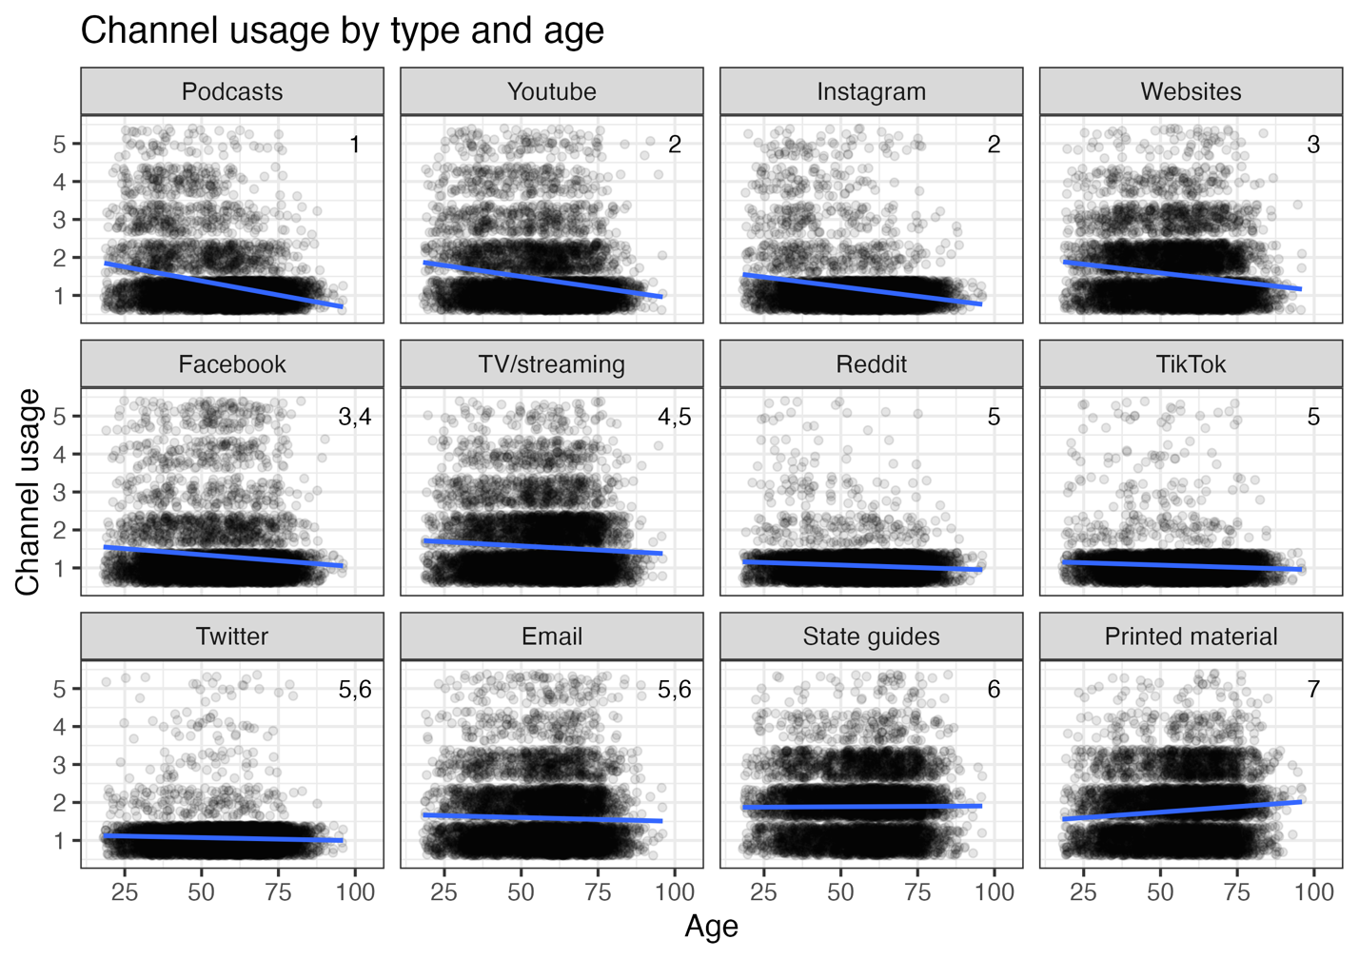

Figure S1: Channel usage by type and age. If two or more panels share the same grouping number (located in the upper right corner of each panel), then we cannot show them to be different. Channel usage ranges from 1 = never, 2 = less than monthly, 3 = monthly, 4 = weekly, 5 = daily. Points are jittered to show density of points more clearly. Linear model fits are displayed by blue thick line, and 95% CI is shown in gray. For corresponding statistics, please see Table S2.

Table S3. Post-hoc analysis of education by channel type interaction for channel usage. The estimate represents the difference between the two estimated marginal means (i.e., an effect size). Results are averaged over the levels of age, club, and sex. P-values are adjusted using the tukey method for comparing multiple estimates. Significance level used: alpha = 0.05. SE = standard error; 95% CI = 95% Confidence Interval.

|  |  |  |  |  |  |  |
| --- | --- | --- | --- | --- | --- | --- |
| Education contrast | Channel type | Estimate | SE | t ratio | p-value |  |
| No or some college - Undergrad degree | Email | -0.115 | 0.043 | -2.678 | 0.020 | * |
| No or some college - Higher ed degree | Email | -0.098 | 0.056 | -1.751 | 0.187 |  |
| Undergrad degree - Higher ed degree | Email | 0.016 | 0.067 | 0.241 | 0.969 |  |
| No or some college - Undergrad degree | Facebook | -0.063 | 0.044 | -1.444 | 0.318 |  |
| No or some college - Higher ed degree | Facebook | -0.065 | 0.061 | -1.063 | 0.537 |  |
| Undergrad degree - Higher ed degree | Facebook | -0.002 | 0.071 | -0.031 | 0.999 |  |
| No or some college - Undergrad degree | Instagram | -0.078 | 0.040 | -1.943 | 0.127 |  |
| No or some college - Higher ed degree | Instagram | 0.013 | 0.052 | 0.239 | 0.969 |  |
| Undergrad degree - Higher ed degree | Instagram | 0.091 | 0.061 | 1.485 | 0.298 |  |
| No or some college - Undergrad degree | Podcasts | -0.133 | 0.042 | -3.155 | 0.005 | * |
| No or some college - Higher ed degree | Podcasts | -0.168 | 0.057 | -2.926 | 0.010 | * |
| Undergrad degree - Higher ed degree | Podcasts | -0.035 | 0.067 | -0.520 | 0.862 |  |
| No or some college - Undergrad degree | Printed material | 0.045 | 0.043 | 1.048 | 0.547 |  |
| No or some college - Higher ed degree | Printed material | 0.032 | 0.060 | 0.540 | 0.851 |  |
| Undergrad degree - Higher ed degree | Printed material | -0.013 | 0.068 | -0.185 | 0.981 |  |
| No or some college - Undergrad degree | Reddit | 0.045 | 0.044 | 1.028 | 0.559 |  |
| No or some college - Higher ed degree | Reddit | 0.070 | 0.060 | 1.170 | 0.471 |  |
| Undergrad degree - Higher ed degree | Reddit | 0.025 | 0.070 | 0.363 | 0.930 |  |
| No or some college - Undergrad degree | State hunting & fishing guides | -0.012 | 0.036 | -0.326 | 0.943 |  |
| No or some college - Higher ed degree | State hunting & fishing guides | 0.003 | 0.044 | 0.071 | 0.997 |  |
| Undergrad degree - Higher ed degree | State hunting & fishing guides | 0.015 | 0.052 | 0.287 | 0.956 |  |
| No or some college - Undergrad degree | TV/streaming | 0.057 | 0.036 | 1.551 | 0.267 |  |
| No or some college - Higher ed degree | TV/streaming | 0.053 | 0.044 | 1.212 | 0.446 |  |
| Undergrad degree - Higher ed degree | TV/streaming | -0.003 | 0.050 | -0.063 | 0.998 |  |
| No or some college - Undergrad degree | Tiktok | 0.009 | 0.035 | 0.244 | 0.968 |  |
| No or some college - Higher ed degree | Tiktok | -0.008 | 0.043 | -0.193 | 0.980 |  |
| Undergrad degree - Higher ed degree | Tiktok | -0.017 | 0.051 | -0.335 | 0.940 |  |
| No or some college - Undergrad degree | Twitter | -0.075 | 0.043 | -1.761 | 0.183 |  |
| No or some college - Higher ed degree | Twitter | -0.100 | 0.057 | -1.746 | 0.188 |  |
| Undergrad degree - Higher ed degree | Twitter | -0.025 | 0.067 | -0.374 | 0.926 |  |
| No or some college - Undergrad degree | Websites | -0.072 | 0.042 | -1.708 | 0.202 |  |
| No or some college - Higher ed degree | Websites | -0.087 | 0.055 | -1.585 | 0.252 |  |
| Undergrad degree - Higher ed degree | Websites | -0.015 | 0.063 | -0.238 | 0.969 |  |
| No or some college - Undergrad degree | Youtube | -0.031 | 0.041 | -0.754 | 0.731 |  |
| No or some college - Higher ed degree | Youtube | -0.072 | 0.054 | -1.334 | 0.376 |  |
| Undergrad degree - Higher ed degree | Youtube | -0.041 | 0.061 | -0.668 | 0.782 |  |

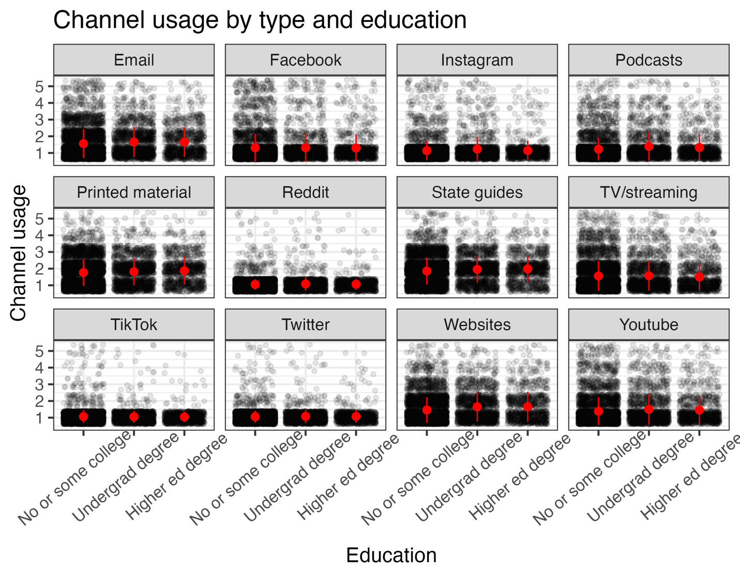Figure S2. Channel usage by education and channel type. Channel usage ranges from 1 = never, 2 = less than monthly, 3 = monthly, 4 = weekly, 5 = daily. Points are jittered to show density of points more clearly. Means are displayed by red points, and standard deviation is shown by point range. For corresponding statistics, please see Table S3.Table S4. Post-hoc analysis of club membership by channel type interaction for channel usage. The estimate represents the difference between the two estimated marginal means (i.e., an effect size). Results are averaged over the levels of age, education, and sex. P-values are adjusted using the tukey method for comparing multiple estimates. Comparisons are only made within each channel type. Significance level used: alpha = 0.05. SE = standard error; 95% CI = 95% Confidence Interval.

|  |  |  |  |  |  |  |
| --- | --- | --- | --- | --- | --- | --- |
| Club membership contrast | Channel type | Estimate | SE | t-ratio | p-value |  |
| No - Yes | Podcasts | -0.067 | 0.041 | -1.633 | 0.102 |  |
| No - Yes | Youtube | -0.126 | 0.043 | -2.929 | 0.003 | * |
| No - Yes | Instagram | -0.051 | 0.039 | -1.309 | 0.191 |  |
| No - Yes | Websites | -0.117 | 0.041 | -2.855 | 0.004 | * |
| No - Yes | Facebook | -0.070 | 0.041 | -1.691 | 0.091 |  |
| No - Yes | TV/streaming | -0.125 | 0.043 | -2.937 | 0.003 | * |
| No - Yes | Reddit | -0.059 | 0.035 | -1.675 | 0.094 |  |
| No - Yes | Tiktok | -0.045 | 0.035 | -1.311 | 0.190 |  |
| No - Yes | X (Twitter) | -0.039 | 0.034 | -1.119 | 0.263 |  |
| No - Yes | Email | -0.102 | 0.041 | -2.463 | 0.014 | * |
| No - Yes | State hunting & fishing guides | -0.116 | 0.040 | -2.906 | 0.004 | * |
| No - Yes | Printed material | -0.153 | 0.040 | -3.842 | 0.000 | * |

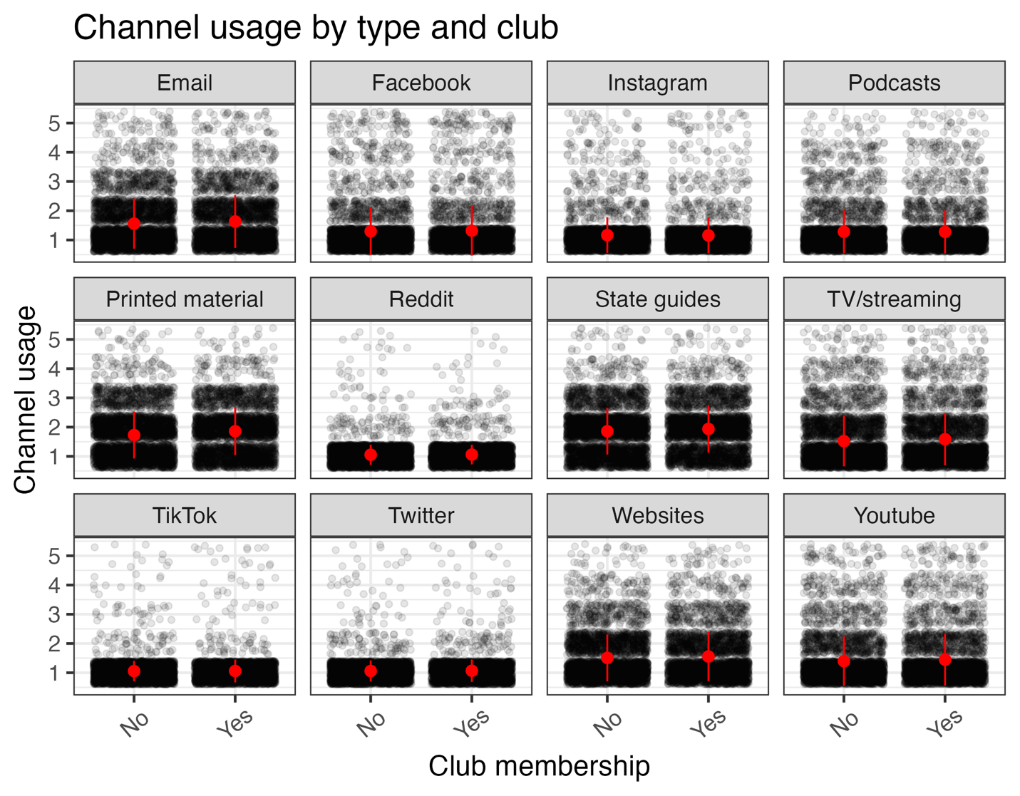

Figure S3. Channel usage by club membership and channel type. Channel usage ranges from 1 = never, 2 = less than monthly, 3 = monthly, 4 = weekly, 5 = daily. Points are jittered to show density of points more clearly. Means are displayed by red points, and standard deviation is shown by point range. For corresponding statistics, please see Table S4.Table S5. Post-hoc analysis of sex by channel type interaction for channel usage. The estimate represents the difference between the two estimated marginal means (i.e., an effect size). Results are averaged over the levels of age, education, and club membership. P-values are adjusted using the tukey method for comparing multiple estimates. Comparisons are only made within each channel type. Significance level used: alpha = 0.05. SE = standard error; 95% CI = 95% Confidence Interval.

|  |  |  |  |  |  |  |
| --- | --- | --- | --- | --- | --- | --- |
| Sex contrast | Channel type | Estimate | SE | t-ratio | p.value |  |
| Female - Male | Podcasts | -0.191 | 0.055 | -3.489 | 0.000 | * |
| Female - Male | Youtube | -0.155 | 0.070 | -2.224 | 0.026 | * |
| Female - Male | Instagram | -0.042 | 0.054 | -0.771 | 0.440 |  |
| Female - Male | Websites | -0.018 | 0.063 | -0.289 | 0.772 |  |
| Female - Male | Facebook | 0.056 | 0.064 | 0.873 | 0.383 |  |
| Female - Male | TV/streaming | -0.002 | 0.070 | -0.022 | 0.983 |  |
| Female - Male | Reddit | 0.005 | 0.031 | 0.176 | 0.860 |  |
| Female - Male | TikTok | 0.074 | 0.038 | 1.963 | 0.050 | * |
| Female - Male | X (Twitter) | 0.042 | 0.033 | 1.263 | 0.207 |  |
| Female - Male | Email | 0.006 | 0.064 | 0.093 | 0.926 |  |
| Female - Male | State hunting & fishing guides | 0.104 | 0.061 | 1.722 | 0.085 |  |
| Female - Male | Printed material | 0.052 | 0.060 | 0.859 | 0.390 |  |

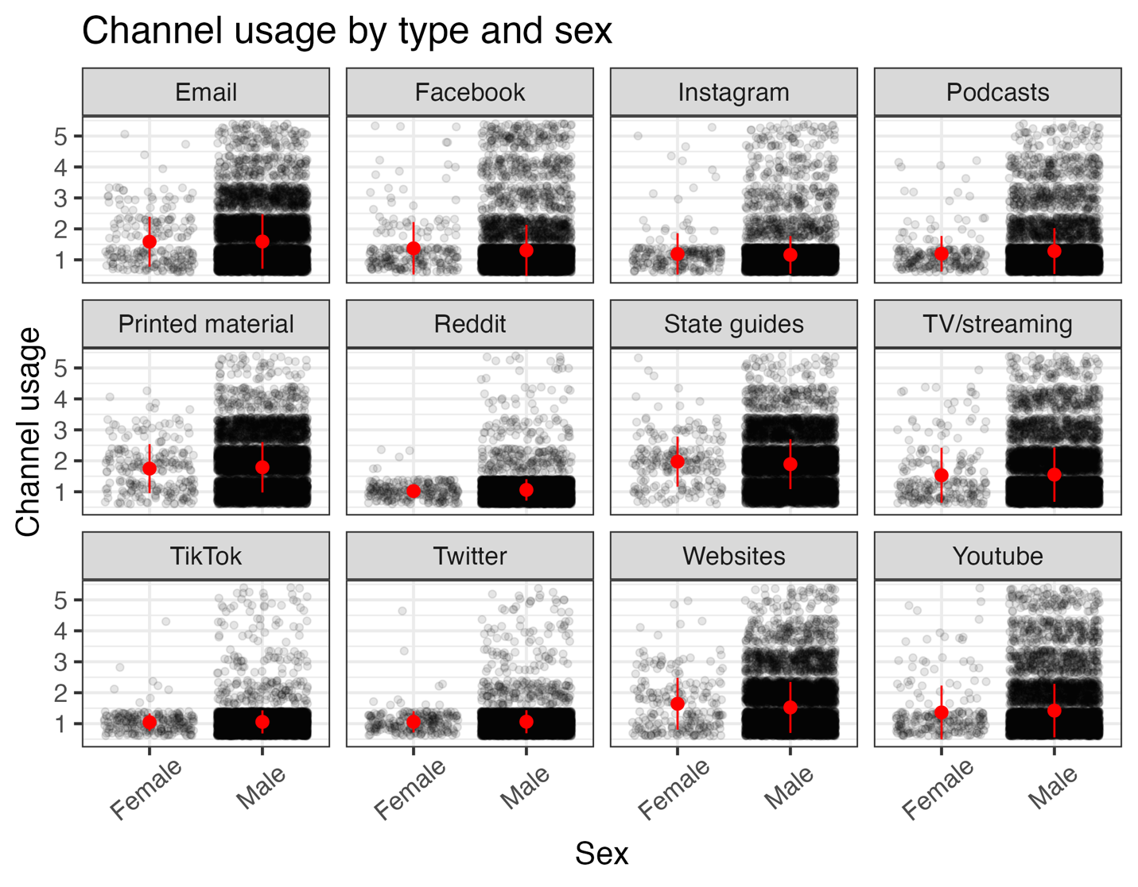

Figure S4. Channel usage by channel type and sex. Channel usage ranges from 1 = never, 2 = less than monthly, 3 = monthly, 4 = weekly, 5 = daily. Points are jittered to show density of points more clearly. Means are displayed by red points, and standard devition is shown by point range. For corresponding statistics, please see Table S5.Table S6. Post-hoc analysis of sex by age interaction for channel usage. Results are averaged over the levels of channel type, club, and education. P-values are adjusted using the tukey method for comparing multiple estimates. Significance level used: alpha = 0.05. If two or more groups share the number (under “Group” column), then we cannot show them to be different.

|  |  |  |  |  |  |
| --- | --- | --- | --- | --- | --- |
| Sex | Estimate | SE | 95% CI | | Group |
| Male | -0.087 | 0.008 | -0.104 | -0.071 | 1 |
| Female | 0.008 | 0.029 | -0.05 | 0.065 | 2 |

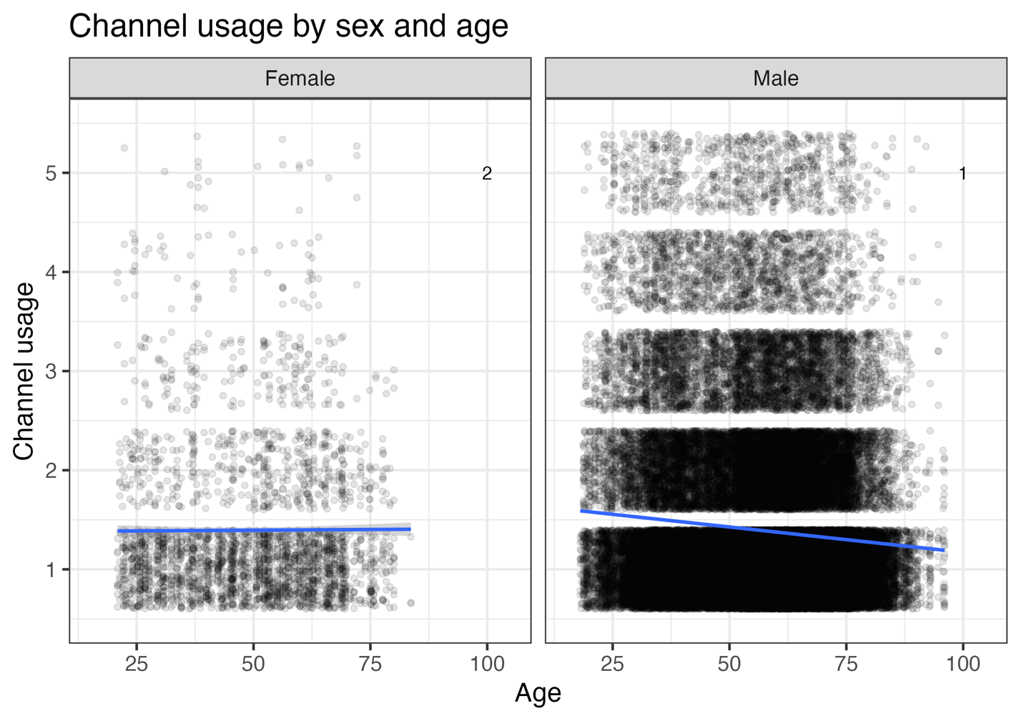

Figure S5. Channel usage by sex and age. Channel usage ranges from 1 = never, 2 = less than monthly, 3 = monthly, 4 = weekly, 5 = daily. Points are jittered to show density of points more clearly. Linear model fits are displayed by blue thick line, and 95% CI is shown in gray. For corresponding statistics, please see Table S6.

Table S7. Beta coefficients for the linear regression model where source trust is the response variable. We include the mean as well as the lower and upper 95% confidence interval for each variable and level in the model.

|  |  |  |  |
| --- | --- | --- | --- |
| Explanatory variable and level | Mean | Lower | Upper |
| (Intercept) | 3.983 | 3.821 | 4.144 |
| sourceCelebrity_hunters | -1.067 | -1.257 | -0.878 |
| sourceCWD_specific_orgs | -0.055 | -0.183 | 0.074 |
| sourceDeer_farm_organizations | -0.772 | -0.949 | -0.594 |
| sourceFederal_wildlife_agencies | 0.158 | 0.054 | 0.261 |
| sourceFriends_or_other_hunters | -0.645 | -0.835 | -0.455 |
| sourceHunter_education_course | 0.074 | -0.054 | 0.202 |
| sourceHunters_followed_on_social_media | -0.914 | -1.103 | -0.725 |
| sourceHunting_apparel_companies | -0.914 | -1.096 | -0.733 |
| sourceHunting_Orgs | -0.398 | -0.547 | -0.250 |
| sourceHunting_publications | -0.322 | -0.470 | -0.174 |
| sourceHunting_retailers | -0.792 | -0.980 | -0.604 |
| sourceSports_orgs | -0.466 | -0.643 | -0.288 |
| sourceState_wildlife_agency | 0.220 | 0.106 | 0.334 |
| age_standard | -0.013 | -0.095 | 0.068 |
| edUndergrad degree | 0.196 | -0.018 | 0.410 |
| edHigher ed degree | 0.145 | -0.070 | 0.360 |
| clubYes | -0.147 | -0.305 | 0.011 |
| sexMale | -0.180 | -0.344 | -0.016 |
| sourceCelebrity_hunters:age_standard | -0.014 | -0.044 | 0.017 |
| sourceCWD_specific_orgs:age_standard | 0.029 | 0.006 | 0.053 |
| sourceDeer_farm_organizations:age_standard | 0.045 | 0.013 | 0.077 |
| sourceFederal_wildlife_agencies:age_standard | 0.081 | 0.060 | 0.101 |
| sourceFriends_or_other_hunters:age_standard | 0.033 | 0.003 | 0.063 |
| sourceHunter_education_course:age_standard | 0.044 | 0.020 | 0.067 |
| sourceHunters_followed_on_social_media:age_standard | -0.022 | -0.053 | 0.008 |
| sourceHunting_apparel_companies:age_standard | -0.007 | -0.037 | 0.022 |
| sourceHunting_Orgs:age_standard | 0.034 | 0.010 | 0.058 |
| sourceHunting_publications:age_standard | 0.076 | 0.052 | 0.099 |
| sourceHunting_retailers:age_standard | 0.006 | -0.022 | 0.034 |
| sourceSports_orgs:age_standard | 0.111 | 0.080 | 0.142 |
| sourceState_wildlife_agency:age_standard | 0.118 | 0.096 | 0.139 |
| sourceCelebrity_hunters:edUndergrad degree | -0.271 | -0.350 | -0.192 |
| sourceCWD_specific_orgs:edUndergrad degree | -0.164 | -0.221 | -0.107 |
| sourceDeer_farm_organizations:edUndergrad degree | -0.368 | -0.448 | -0.288 |
| sourceFederal_wildlife_agencies:edUndergrad degree | -0.088 | -0.136 | -0.040 |
| sourceFriends_or_other_hunters:edUndergrad degree | -0.288 | -0.365 | -0.210 |
| sourceHunter_education_course:edUndergrad degree | -0.193 | -0.250 | -0.136 |
| sourceHunters_followed_on_social_media:edUndergrad degree | -0.320 | -0.401 | -0.239 |
| sourceHunting_apparel_companies:edUndergrad degree | -0.296 | -0.370 | -0.221 |
| sourceHunting_Orgs:edUndergrad degree | -0.192 | -0.254 | -0.129 |
| sourceHunting_publications:edUndergrad degree | -0.168 | -0.230 | -0.106 |
| sourceHunting_retailers:edUndergrad degree | -0.296 | -0.368 | -0.223 |
| sourceSports_orgs:edUndergrad degree | -0.317 | -0.392 | -0.241 |
| sourceState_wildlife_agency:edUndergrad degree | -0.049 | -0.099 | 0.001 |
| sourceCelebrity_hunters:edHigher ed degree | -0.443 | -0.541 | -0.345 |
| sourceCWD_specific_orgs:edHigher ed degree | -0.222 | -0.297 | -0.148 |
| sourceDeer_farm_organizations:edHigher ed degree | -0.500 | -0.607 | -0.392 |
| sourceFederal_wildlife_agencies:edHigher ed degree | -0.103 | -0.171 | -0.035 |
| sourceFriends_or_other_hunters:edHigher ed degree | -0.364 | -0.463 | -0.266 |
| sourceHunter_education_course:edHigher ed degree | -0.212 | -0.289 | -0.134 |
| sourceHunters_followed_on_social_media:edHigher ed degree | -0.462 | -0.563 | -0.362 |
| sourceHunting_apparel_companies:edHigher ed degree | -0.396 | -0.494 | -0.299 |
| sourceHunting_Orgs:edHigher ed degree | -0.265 | -0.349 | -0.181 |
| sourceHunting_publications:edHigher ed degree | -0.277 | -0.356 | -0.197 |
| sourceHunting_retailers:edHigher ed degree | -0.432 | -0.527 | -0.336 |
| sourceSports_orgs:edHigher ed degree | -0.508 | -0.619 | -0.398 |
| sourceState_wildlife_agency:edHigher ed degree | -0.064 | -0.130 | 0.003 |
| sourceCelebrity_hunters:clubYes | 0.111 | 0.047 | 0.174 |
| sourceCWD_specific_orgs:clubYes | 0.040 | -0.007 | 0.088 |
| sourceDeer_farm_organizations:clubYes | 0.070 | 0.006 | 0.134 |
| sourceFederal_wildlife_agencies:clubYes | 0.022 | -0.020 | 0.064 |
| sourceFriends_or_other_hunters:clubYes | 0.084 | 0.022 | 0.146 |
| sourceHunter_education_course:clubYes | 0.093 | 0.045 | 0.140 |
| sourceHunters_followed_on_social_media:clubYes | 0.097 | 0.034 | 0.160 |
| sourceHunting_apparel_companies:clubYes | 0.060 | -0.001 | 0.122 |
| sourceHunting_Orgs:clubYes | 0.145 | 0.094 | 0.195 |
| sourceHunting_publications:clubYes | 0.107 | 0.057 | 0.157 |
| sourceHunting_retailers:clubYes | 0.090 | 0.031 | 0.149 |
| sourceSports_orgs:clubYes | 0.202 | 0.139 | 0.264 |
| sourceState_wildlife_agency:clubYes | 0.052 | 0.009 | 0.095 |
| sourceCelebrity_hunters:sexMale | 0.298 | 0.107 | 0.489 |
| sourceCWD_specific_orgs:sexMale | -0.041 | -0.173 | 0.090 |
| sourceDeer_farm_organizations:sexMale | 0.124 | -0.055 | 0.304 |
| sourceFederal_wildlife_agencies:sexMale | -0.011 | -0.121 | 0.099 |
| sourceFriends_or_other_hunters:sexMale | 0.255 | 0.065 | 0.446 |
| sourceHunter_education_course:sexMale | 0.066 | -0.063 | 0.196 |
| sourceHunters_followed_on_social_media:sexMale | 0.252 | 0.058 | 0.446 |
| sourceHunting_apparel_companies:sexMale | 0.198 | 0.014 | 0.382 |
| sourceHunting_Orgs:sexMale | 0.236 | 0.085 | 0.387 |
| sourceHunting_publications:sexMale | 0.172 | 0.019 | 0.324 |
| sourceHunting_retailers:sexMale | 0.198 | 0.008 | 0.388 |
| sourceSports_orgs:sexMale | 0.139 | -0.041 | 0.318 |
| sourceState_wildlife_agency:sexMale | 0.026 | -0.089 | 0.142 |
| age_standard:sexMale | -0.033 | -0.110 | 0.043 |
| age_standard:edUndergrad degree | -0.006 | -0.038 | 0.027 |
| age_standard:edHigher ed degree | 0.007 | -0.035 | 0.050 |
| age_standard:clubYes | 0.033 | 0.003 | 0.062 |
| edUndergrad degree:sexMale | -0.008 | -0.214 | 0.198 |
| edHigher ed degree:sexMale | 0.030 | -0.179 | 0.239 |
| clubYes:sexMale | 0.084 | -0.069 | 0.236 |
| edUndergrad degree:clubYes | 0.020 | -0.050 | 0.090 |
| edHigher ed degree:clubYes | 0.150 | 0.065 | 0.235 |

Table S8. Post-hoc analysis of source type by age interaction for source trustworthiness. Estimate refers to the estimated marginal means of linear trends. Results are averaged over the levels of: education, club membership, and sex. P-values are adjusted using the tukey method for comparing multiple estimates. Significance level used: alpha = 0.05. If two or more groups share the number (under “Group” column), then we cannot show them to be different. CWD = Chronic Wasting Disease. SE = standard error; 95% CI = 95% Confidence Interval.

|  |  |  |  |  |  |
| --- | --- | --- | --- | --- | --- |
| Source type | Estimate | SE | 95% CI | | Group |
| Hunters followed on social media | -0.035 | 0.022 | -0.078 | 0.008 | 1 |
| Celebrity hunters | -0.027 | 0.021 | -0.068 | 0.015 | 1,2 |
| Hunting apparel companies | -0.02 | 0.022 | -0.063 | 0.022 | 1,2 |
| Academics and researchers | -0.013 | 0.022 | -0.056 | 0.03 | 1,2,3 |
| Hunting retailers | -0.007 | 0.021 | -0.048 | 0.034 | 1,2,3,4 |
| CWD specific orgs | 0.016 | 0.022 | -0.026 | 0.059 | 1,2,3,4 |
| Friends or other hunters | 0.02 | 0.021 | -0.022 | 0.062 | 2,3,4,5 |
| Hunting Orgs | 0.021 | 0.022 | -0.022 | 0.063 | 2,3,4 |
| Hunter education course | 0.031 | 0.022 | -0.012 | 0.073 | 4,5 |
| Deer farm organizations | 0.032 | 0.022 | -0.012 | 0.076 | 3,4,5 |
| Hunting publications | 0.063 | 0.022 | 0.02 | 0.105 | 5,6 |
| Federal wildlife agencies | 0.068 | 0.022 | 0.024 | 0.111 | 5,6 |
| Sports organizations | 0.098 | 0.023 | 0.054 | 0.143 | 6,7 |
| State wildlife agency | 0.105 | 0.022 | 0.061 | 0.148 | 7 |

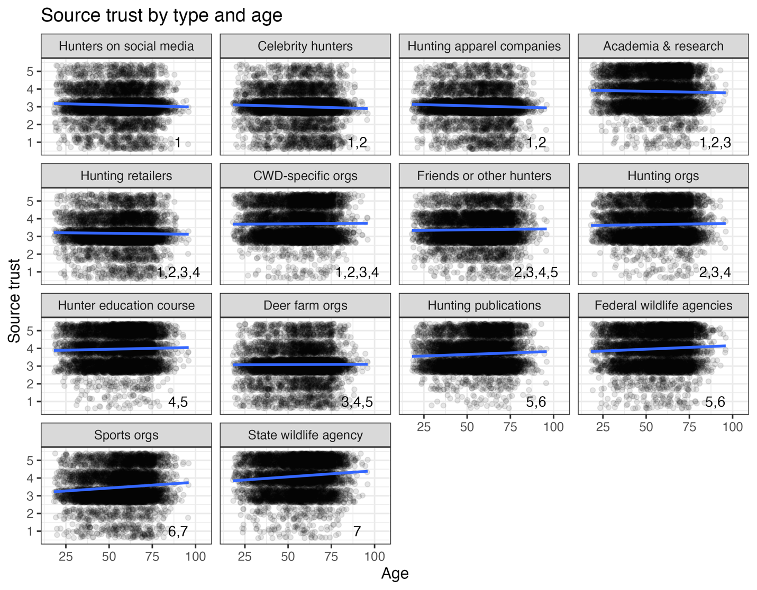

Figure S6. Source trust by type and age. If two or more panels share the same grouping number (located in the lower right corner of each panel), then we cannot show them to be different. Source trust ranges from 1 = completely disagree, 2 = somewhat disagree, 3 = no opinion, 4 = somewhat agree, 5 = completely agree. Points are jittered to show density of points more clearly. Linear model fits are displayed by blue thick line, and 95% Confidence Interval is shown in gray. For corresponding statistics, please see Table S8.

Table S9. Post-hoc analysis of source type and education for source trust. The estimate represents the difference between the two estimated marginal means (i.e., an effect size). Results are averaged over the levels of: age, club, and sex. P-values are adjustment using the tukey method for comparing a family of multiple estimates. Significance level used: alpha = 0.05. SE = standard error; 95% CI = 95% Confidence Interval.

|  |  |  |  |  |  |  |
| --- | --- | --- | --- | --- | --- | --- |
| Education contrast | Source type | Estimate | SE | t.ratio | p.value |  |
| No or some college - Undergrad degree | Academics and researchers | -0.202 | 0.057 | -3.535 | 0.001 | * |
| No or some college - Higher ed degree | Academics and researchers | -0.235 | 0.060 | -3.900 | 0.000 | * |
| Undergrad degree - Higher ed degree | Academics and researchers | -0.033 | 0.068 | -0.482 | 0.880 |  |
| No or some college - Undergrad degree | Celebrity hunters | 0.069 | 0.057 | 1.215 | 0.444 |  |
| No or some college - Higher ed degree | Celebrity hunters | 0.208 | 0.060 | 3.477 | 0.001 | * |
| Undergrad degree - Higher ed degree | Celebrity hunters | 0.139 | 0.070 | 1.988 | 0.115 |  |
| No or some college - Undergrad degree | CWD specific orgs | -0.038 | 0.056 | -0.676 | 0.778 |  |
| No or some college - Higher ed degree | CWD specific orgs | -0.013 | 0.058 | -0.219 | 0.974 |  |
| Undergrad degree - Higher ed degree | CWD specific orgs | 0.026 | 0.066 | 0.385 | 0.922 |  |
| No or some college - Undergrad degree | Deer farm organizations | 0.166 | 0.058 | 2.867 | 0.012 | * |
| No or some college - Higher ed degree | Deer farm organizations | 0.265 | 0.060 | 4.424 | 0.000 | * |
| Undergrad degree - Higher ed degree | Deer farm organizations | 0.099 | 0.069 | 1.437 | 0.322 |  |
| No or some college - Undergrad degree | Federal wildlife agencies | -0.114 | 0.057 | -1.999 | 0.112 |  |
| No or some college - Higher ed degree | Federal wildlife agencies | -0.132 | 0.061 | -2.160 | 0.078 |  |
| Undergrad degree - Higher ed degree | Federal wildlife agencies | -0.018 | 0.069 | -0.261 | 0.963 |  |
| No or some college - Undergrad degree | Friends or other hunters | 0.085 | 0.055 | 1.546 | 0.269 |  |
| No or some college - Higher ed degree | Friends or other hunters | 0.129 | 0.059 | 2.176 | 0.075 |  |
| Undergrad degree - Higher ed degree | Friends or other hunters | 0.044 | 0.068 | 0.643 | 0.797 |  |
| No or some college - Undergrad degree | Hunter education course | -0.009 | 0.056 | -0.165 | 0.985 |  |
| No or some college - Higher ed degree | Hunter education course | -0.023 | 0.062 | -0.376 | 0.925 |  |
| Undergrad degree - Higher ed degree | Hunter education course | -0.014 | 0.069 | -0.203 | 0.978 |  |
| No or some college - Undergrad degree | Hunters followed on social media | 0.118 | 0.058 | 2.042 | 0.102 |  |
| No or some college - Higher ed degree | Hunters followed on social media | 0.227 | 0.060 | 3.813 | 0.000 | * |
| Undergrad degree - Higher ed degree | Hunters followed on social media | 0.109 | 0.069 | 1.578 | 0.255 |  |
| No or some college - Undergrad degree | Hunting apparel companies | 0.093 | 0.057 | 1.650 | 0.225 |  |
| No or some college - Higher ed degree | Hunting apparel companies | 0.161 | 0.060 | 2.697 | 0.019 | * |
| Undergrad degree - Higher ed degree | Hunting apparel companies | 0.068 | 0.068 | 0.995 | 0.580 |  |
| No or some college - Undergrad degree | Hunting Orgs | -0.010 | 0.056 | -0.184 | 0.981 |  |
| No or some college - Higher ed degree | Hunting Orgs | 0.030 | 0.061 | 0.497 | 0.873 |  |
| Undergrad degree - Higher ed degree | Hunting Orgs | 0.040 | 0.069 | 0.586 | 0.828 |  |
| No or some college - Undergrad degree | Hunting publications | -0.035 | 0.056 | -0.615 | 0.812 |  |
| No or some college - Higher ed degree | Hunting publications | 0.042 | 0.059 | 0.713 | 0.756 |  |
| Undergrad degree - Higher ed degree | Hunting publications | 0.076 | 0.067 | 1.139 | 0.490 |  |
| No or some college - Undergrad degree | Hunting retailers | 0.094 | 0.055 | 1.710 | 0.201 |  |
| No or some college - Higher ed degree | Hunting retailers | 0.197 | 0.058 | 3.418 | 0.002 | * |
| Undergrad degree - Higher ed degree | Hunting retailers | 0.103 | 0.065 | 1.575 | 0.256 |  |
| No or some college - Undergrad degree | Sports orgs | 0.114 | 0.058 | 1.986 | 0.116 |  |
| No or some college - Higher ed degree | Sports orgs | 0.273 | 0.065 | 4.193 | 0.000 | * |
| Undergrad degree - Higher ed degree | Sports orgs | 0.159 | 0.074 | 2.154 | 0.079 |  |
| No or some college - Undergrad degree | State wildlife agency | -0.153 | 0.057 | -2.702 | 0.019 | * |
| No or some college - Higher ed degree | State wildlife agency | -0.171 | 0.061 | -2.824 | 0.013 | * |
| Undergrad degree - Higher ed degree | State wildlife agency | -0.018 | 0.068 | -0.259 | 0.964 |  |

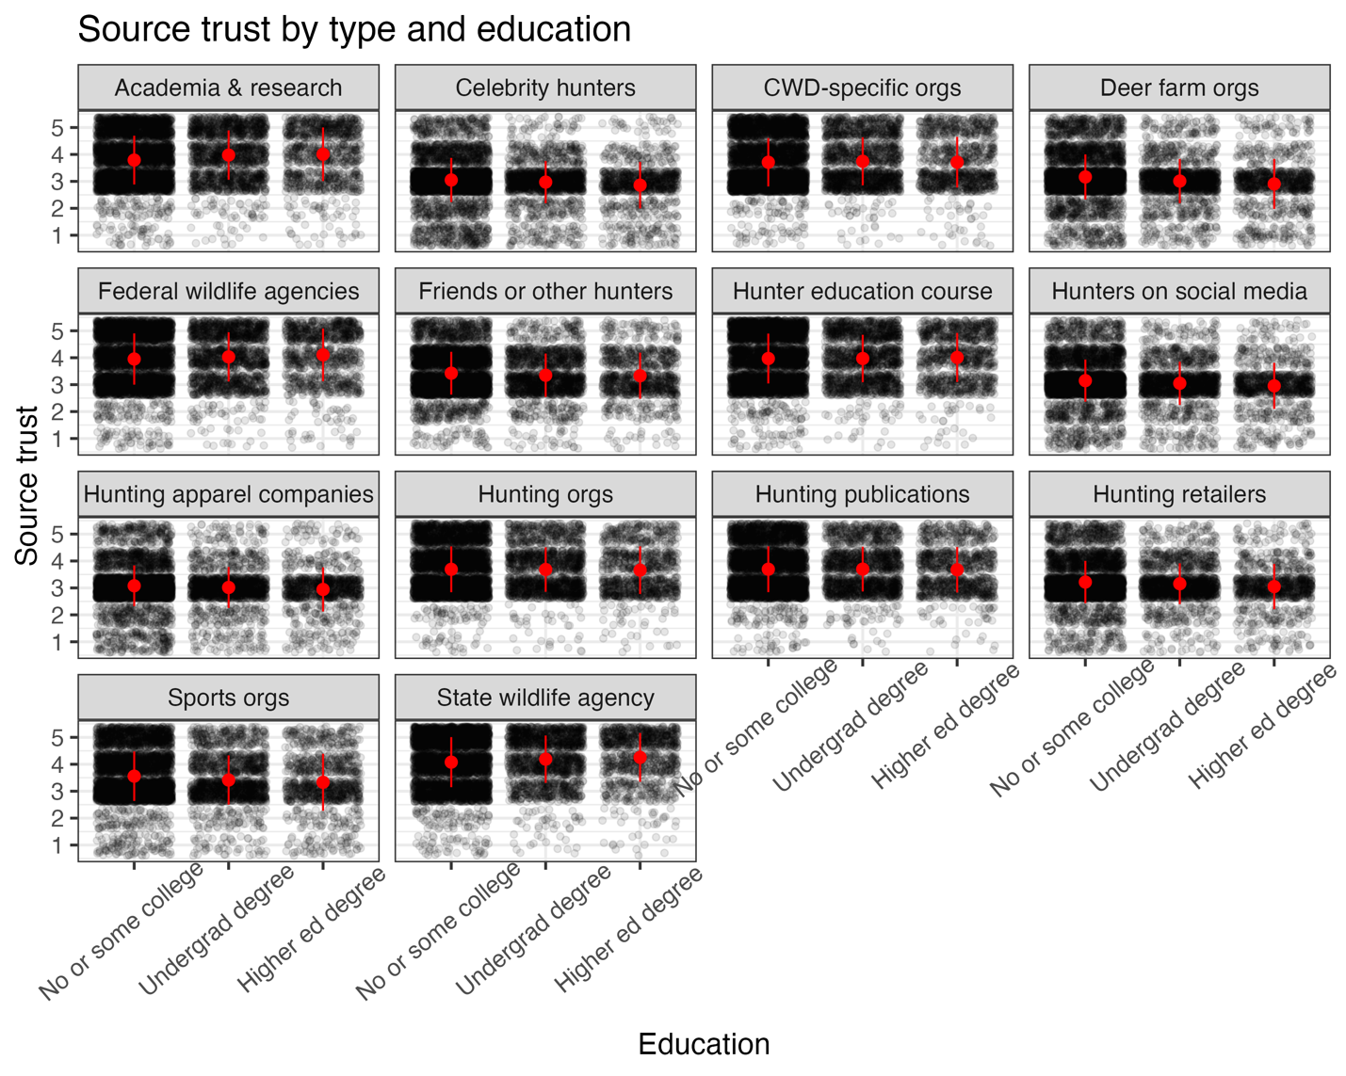Figure S7. Source type and education. Points are jittered to show density of points more clearly. Means are displayed by red points, and standard deviation is shown by point range. For corresponding statistics, please see Table S9.

Table S10. Post-hoc analysis of source type and club for source trust. The estimate represents the difference between the two estimated marginal means (i.e., an effect size). Results are averaged over the levels of: age, education, and sex. P-values are adjustment using the tukey method for comparing a family of multiple estimates. Significance level used: alpha = 0.05. CWD = Chronic Wasting Disease. SE = standard error; 95% CI = 95% Confidence Interval.

|  |  |  |  |  |  |  |
| --- | --- | --- | --- | --- | --- | --- |
| Club contrast | Source type | Estimate | SE | t.ratio | p.value |  |
| No - Yes | Academics and researchers | 0.049 | 0.044 | 1.099 | 0.272 |  |
| No - Yes | Celebrity hunters | -0.062 | 0.043 | -1.427 | 0.154 |  |
| No - Yes | CWD specific orgs | 0.008 | 0.043 | 0.191 | 0.849 |  |
| No - Yes | Deer farm organizations | -0.021 | 0.044 | -0.489 | 0.625 |  |
| No - Yes | Federal wildlife agencies | 0.027 | 0.044 | 0.597 | 0.550 |  |
| No - Yes | Friends or other hunters | -0.036 | 0.042 | -0.848 | 0.397 |  |
| No - Yes | Hunter education course | -0.044 | 0.044 | -0.996 | 0.319 |  |
| No - Yes | Hunters followed on social media | -0.049 | 0.044 | -1.116 | 0.264 |  |
| No - Yes | Hunting apparel companies | -0.012 | 0.044 | -0.264 | 0.792 |  |
| No - Yes | Hunting Orgs | -0.096 | 0.043 | -2.235 | 0.025 | * |
| No - Yes | Hunting publications | -0.059 | 0.043 | -1.375 | 0.169 |  |
| No - Yes | Hunting retailers | -0.042 | 0.042 | -1.003 | 0.316 |  |
| No - Yes | Sports orgs | -0.153 | 0.045 | -3.438 | 0.001 | * |
| No - Yes | State wildlife agency | -0.004 | 0.044 | -0.079 | 0.937 |  |

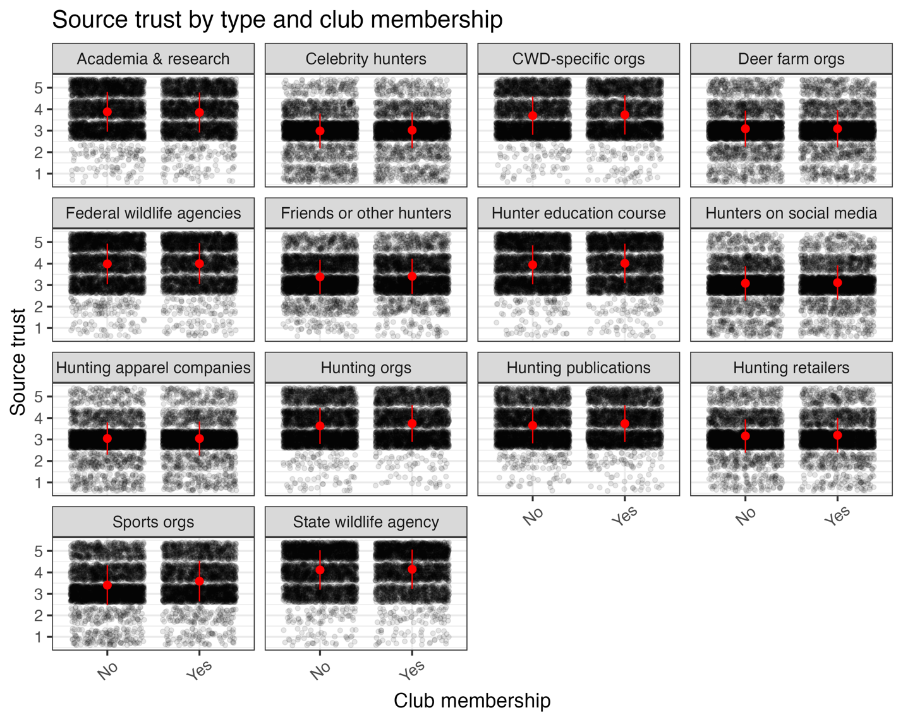

Figure S8. Source type and club. Points are jittered to show density of points more clearly. Means are displayed by red points, and standard deviation is shown by point range. For corresponding statistics, please see Table S10.

Table S11. Post-hoc analysis of source type and sex for source trust. The estimate represents the difference between the two estimated marginal means (i.e., an effect size). Results are averaged over the levels of: age, education, and club. P-values are adjustment using the tukey method for comparing a family of multiple estimates. Significance level used: alpha = 0.05. CWD = Chronic Wasting Disease. SE = standard error; 95% CI = 95% Confidence Interval.

|  |  |  |  |  |  |  |
| --- | --- | --- | --- | --- | --- | --- |
| Sex contrast | Source type | Estimate | SE | t.ratio | p.value |  |
| Female - Male | Academics and researchers | 0.131 | 0.073 | 1.786 | 0.074 |  |
| Female - Male | Celebrity hunters | -0.167 | 0.080 | -2.097 | 0.036 | * |
| Female - Male | CWD specific orgs | 0.172 | 0.076 | 2.278 | 0.023 | * |
| Female - Male | Deer farm organizations | 0.007 | 0.069 | 0.095 | 0.924 |  |
| Female - Male | Federal wildlife agencies | 0.142 | 0.074 | 1.919 | 0.055 |  |
| Female - Male | Friends or other hunters | -0.124 | 0.078 | -1.595 | 0.111 |  |
| Female - Male | Hunter education course | 0.065 | 0.072 | 0.890 | 0.373 |  |
| Female - Male | Hunters followed on social media | -0.121 | 0.074 | -1.630 | 0.103 |  |
| Female - Male | Hunting apparel companies | -0.068 | 0.072 | -0.939 | 0.348 |  |
| Female - Male | Hunting Orgs | -0.105 | 0.071 | -1.470 | 0.142 |  |
| Female - Male | Hunting publications | -0.041 | 0.066 | -0.619 | 0.536 |  |
| Female - Male | Hunting retailers | -0.067 | 0.070 | -0.950 | 0.342 |  |
| Female - Male | Sports orgs | -0.008 | 0.073 | -0.106 | 0.916 |  |
| Female - Male | State wildlife agency | 0.105 | 0.072 | 1.447 | 0.148 |  |

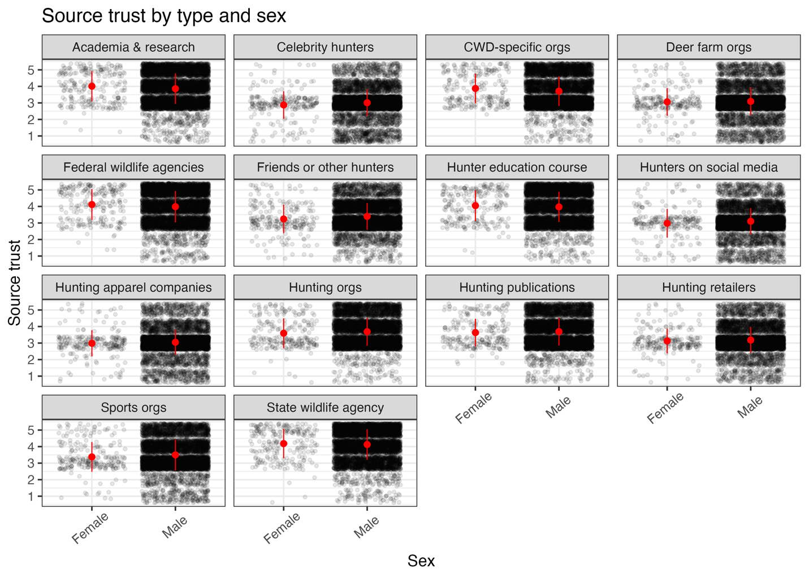

Figure S9. Source type and sex. Points are jittered to show density of points more clearly. Means are displayed by red points, and standard deviation is shown by point range. For corresponding statistics, please see Table S11.

Table S12. Post-hoc analysis of age and club for source trust. Estimate refers to the estimated marginal means of linear trends. Results are averaged over the levels of: source type, education, and sex. P-values are adjustment using the tukey method for comparing a family of multiple estimates. Significance level used: alpha = 0.05. SE = standard error; 95% CI = 95% Confidence Interval.

|  |  |  |  |  |  |
| --- | --- | --- | --- | --- | --- |
| Club | Estimate | SE | 95% CI | | Group |
| No | 0.009 | 0.021 | -0.032 | 0.05 | 1 |
| Yes | 0.041 | 0.021 | 0 | 0.082 | 2 |

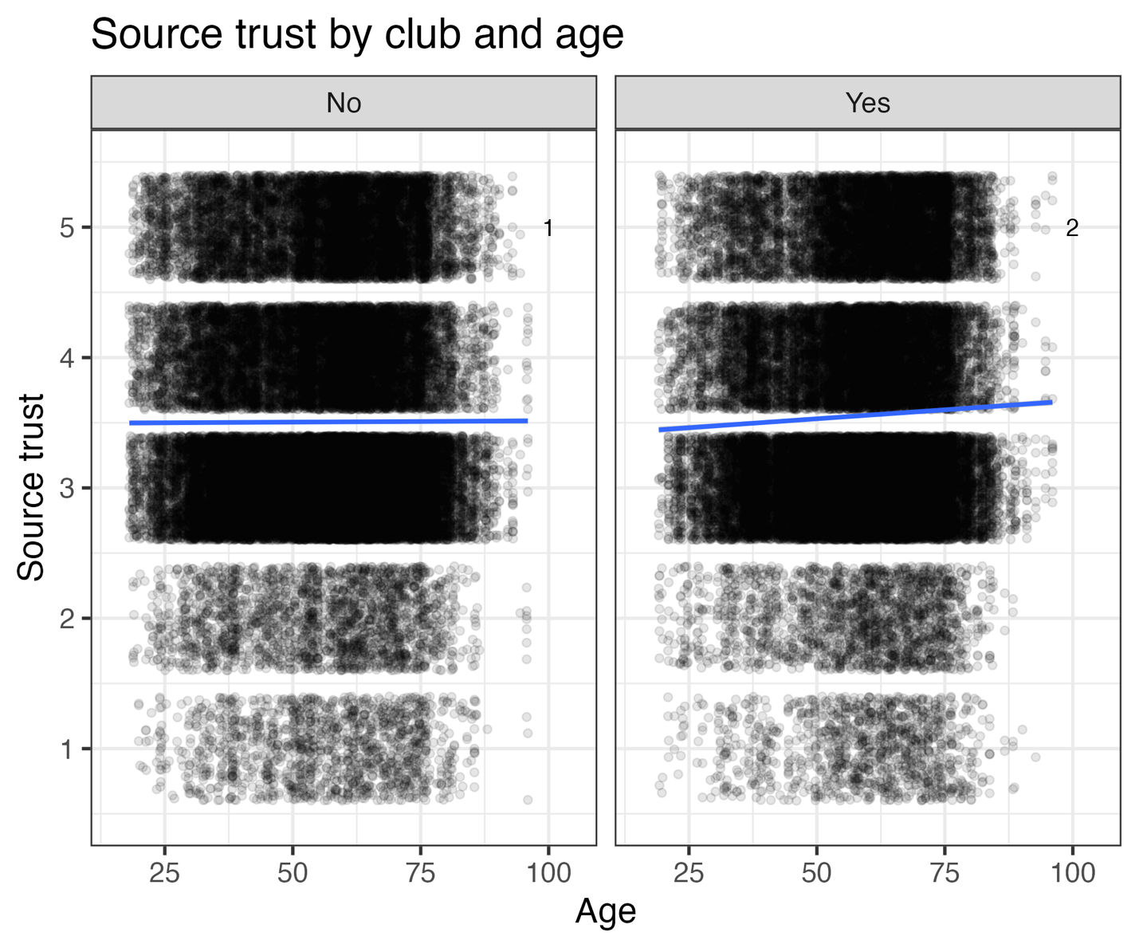

Figure S10. Source trust by club and age. If two or more panels share the same grouping number (located in the lower right corner of each panel), then we cannot show them to be different. Source trust ranges from 1 = completely disagree, 2 = somewhat disagree, 3 = no opinion, 4 = somewhat agree, 5 = completely agree. Points are jittered to show density of points more clearly. Linear model fits are displayed by blue thick line, and 95% CI is shown in gray. For corresponding statistics, please see Table S12.

Table S13. Post-hoc analysis of education and club for source trust. The estimate represents the difference between the two estimated marginal means (i.e., an effect size). Results are averaged over the levels of: source type, sex, and age. P-values are adjustment using the tukey method for comparing a family of multiple estimates. Significance level used: alpha = 0.05. SE = standard error; 95% CI = 95% Confidence Interval.

|  |  |  |  |  |  |
| --- | --- | --- | --- | --- | --- |
| Education contrast | Club | Estimate | SE | t-ratio | p-value |
| No or some college - Undergrad degree | No | 0.023 | 0.056 | 0.402 | 0.915 |
| No or some college - Higher ed degree | No | 0.143 | 0.057 | 2.510 | 0.032* |
| Undergrad degree - Higher ed degree | No | 0.121 | 0.067 | 1.809 | 0.167 |
| No or some college - Undergrad degree | Yes | 0.003 | 0.053 | 0.050 | 0.999 |
| No or some college - Higher ed degree | Yes | -0.006 | 0.055 | -0.115 | 0.993 |
| Undergrad degree - Higher ed degree | Yes | -0.009 | 0.061 | -0.147 | 0.988 |

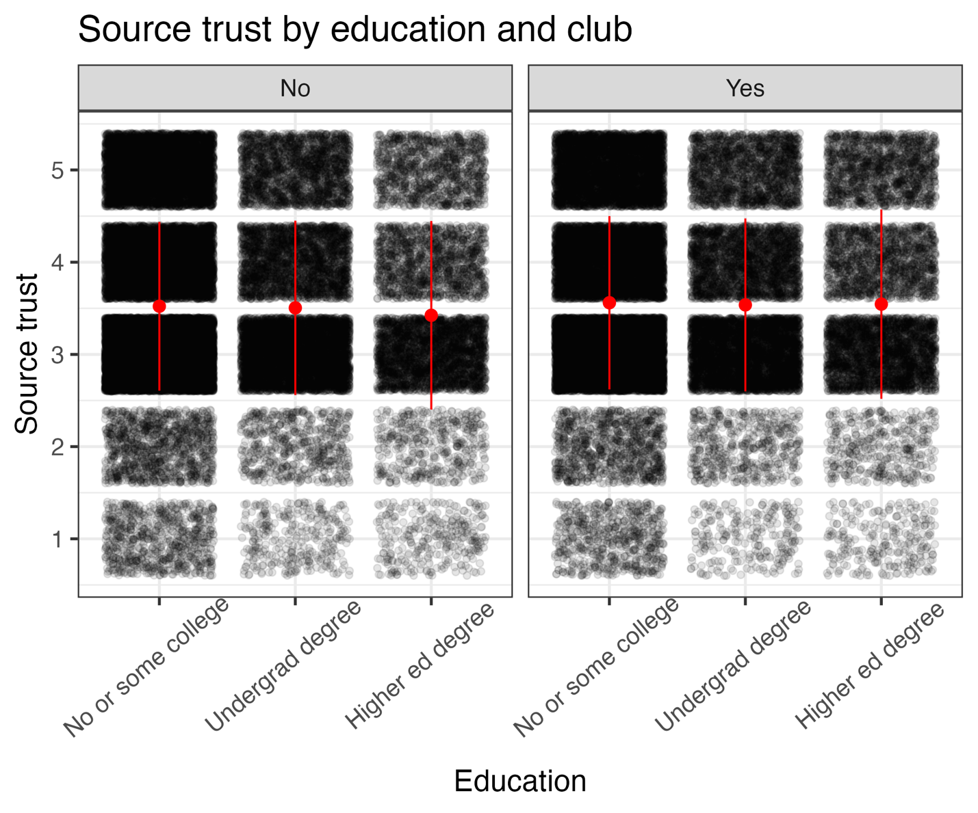

Figure S11. Source trust by education and club. Source trust ranges from 1 = completely disagree, 2 = somewhat disagree, 3 = no opinion, 4 = somewhat agree, 5 = completely agree. Points are jittered to show density of points more clearly. For corresponding statistics, please see Table S13.

Table S14. Variances and covariances reported among variables assessed via a path analysis illustrated in Figure 1B.

|  |  |  |  |  |  |  |
| --- | --- | --- | --- | --- | --- | --- |
|  | Knowledge | Risk | Management | Channel | Source | Trust |
| Knowledge | 0.007 | 0.009 | 0.009 | 0.012 | 0.009 | 0.010 |
| Risk | 0.009 | 0.421 | 0.114 | 0.016 | 0.011 | 0.014 |
| Management | 0.009 | 0.114 | 0.418 | 0.034 | 0.100 | 0.193 |
| Channel | 0.012 | 0.016 | 0.034 | 0.293 | 0.086 | 0.102 |
| Source | 0.009 | 0.011 | 0.100 | 0.086 | 0.342 | 0.425 |
| Trust | 0.010 | 0.014 | 0.193 | 0.102 | 0.425 | 0.849 |

**Massachusetts Deer Hunter Survey**

**Q89** The following survey will include questions to better understand respondents hunting behaviors, knowledge, and opinions which will be used to assist with future management and education programming from MassWildlife. All information collected will be aggregated with no uniquely identifiable information released publicly. Your response is very valuable and we appreciate the time you are taking this survey.

Other than where species are specifically noted, throughout this survey "deer" refers to any member of the deer family including white-tailed deer, elk, caribou, moose, and other related species

**Q6** Have you ever hunted for white-tailed deer?

No

Yes

**Q9** Which of the following other species have you hunted for previously? (select all that apply)

* Caribou
* Elk
* Moose
* Mule Deer
* I have not hunted for any of the other listed species

**Q1** Please select all statements that apply to you:

* I have hunted for white-tailed deer at any point in Massachusetts.
* I have hunted for white-tailed deer in Massachusetts within the last 5 years.
* I have hunted white-tailed deer, mule deer, elk, or moose in a state or Canadian province other than Massachusetts.
* None of the above statements apply to me

**Q51** The following will be a series of questions pertaining to Chronic Wasting Disease (CWD). It is important that your answers to the questions are based on your current knowledge. Please do not do any research or internet searches while you are completing the questions.

**Q52** Have you heard of Chronic Wasting Disease prior to this survey?

* No
* Yes
* I'm not sure

**Q55** What causes CWD?

* Virus
* Bacteria
* Prion
* Environmental toxin (Mercury, PFOAS, microplastics, lead)
* I don't know

**Q56** Below are a list of potential disease transmission pathways. For each possible pathway, please indicate if it has or has not been found to transmit CWD causing prions or if you do not know.

* Naturally occurring in the environment
* Ticks
* Midges
* Mosquitos
* Prions spread in the environments
* Contact between individuals of any of the affected species
* Use of urine lures
* Movement via waterways
* Movement of infected game meat
* Movement of infected captive animals
* Bacterial infections
* Airborne transmission
* Shared salt licks
* Baiting or feeding sites

**Q83** For the following statements, please mark if you think the statement is true, false, or if you do not know.

* CWD can affect an entire state's deer population.
* Some deer are resistant to CWD.
* Deer can develop resistance to CWD by being exposed.
* CWD has been found in Massachusetts.
* Deer infected with CWD will begin looking sick very rapidly (within a few weeks).
* It is not possible to prevent the spread of CWD to new states.
* Having higher deer abundance in an area can increase transmission of CWD between deer.
* CWD is a fatal disease to every deer infected.
* CWD can lead to fewer mature bucks to hunt.
* Moose can get CWD.
* No humans have ever contracted CWD.
* There is no known cure for CWD.
* Deer with CWD will have large black warty growths on their fur.

**Q58** The following is background information about Chronic Wasting Disease (CWD) that may help you with questions for the rest of the survey:

* CWD is caused by a prion, a mis-folded protein, and CWD has been found in wild white-tailed deer, mule deer, red deer, caribou, moose, sika deer and elk. CWD had never been found in Massachusetts or anywhere in New England. New York had a few isolated cases in 2005 at a deer farm near Syracuse, but the nearest areas with CWD in wild deer populations are in Pennsylvania.
* Again - please answer the following questions based on your current knowledge and understanding. Please do not search for any information elsewhere.

**Q108** For the following statements please mark how likely you think the following will occur in the next 10 years. Very Unlikely (1); Somewhat unlikely (2); Neutral (3); Somewhat likely (4); Very likely (5)

* CWD is introduced into Massachusetts from harvested game.
* CWD is introduced into Massachusetts from captive deer movement.
* CWD is introduced into Massachusetts from wild deer movement.
* CWD is introduced into Massachusetts from urine lure products.

**Q110** How concerned are you about the introduction of CWD into Massachusetts?

* Not at all concerned
* Somewhat not concerned
* Neutral
* Somewhat concerned
* Very concerned

**Q100** How important is the prevention of CWD introduction and establishment in Massachusetts deer herds to you?

* Not important
* Low importance
* Neutral
* Moderate importance
* High importance

**Q88** For the following statements, please mark if you think the statement is true, false, or if you do not know.

* CWD typically takes more than a year to kill an infected deer.
* Deer with CWD will have swollen necks and sores around their mouths.
* Male and female deer are equally likely to become infected with CWD.
* There is no risk of spreading CWD from a carcass once the deer is field dressed.
* Venison from CWD states must be deboned prior to being imported into Massachusetts.
* Deer infected with CWD can have no symptoms and still spread CWD.
* Prions that cause CWD can remain in the environment for decades.
* Prions that cause CWD can be spread via feces, saliva, and urine.
* Research suggests that there is no relationship between CWD and human health problems.
* Hunters can play an important role in preventing the spread of CWD.
* Most deer infected with CWD will have visible signs of illness or starvation.

**Q84** For the following statements, please mark your level of agreement. Completely Disagree (1); Somewhat Disagree (2); No Opinion (3); Somewhat Agree (4); Completely Agree (5)

* Wildlife agencies should not do anything to try to limit the spread of CWD.
* CWD would harm Massachusetts wild deer populations if introduced.
* CWD is used as an excuse to reduce deer densities.
* The impact of CWD is exaggerated.
* Urine lures can spread CWD.
* Baiting/feeding deer can increase transmission of CWD.
* If using deer urine lures can spread CWD, it should be banned.
* If CWD was found in Massachusetts, then antlerless permit allocations should be increased to reduce density for preventing further spread of the prions.

**Q74** How has the emergence of CWD impacted where you hunt? (select all that apply)

* I stopped hunting in CWD positive states
* I stopped hunting in areas of states with high CWD rates
* I increased the amount of time I spent hunting
* I decreased the amount of time I spent hunting
* I increased my amount of hunting in CWD areas with higher tag or permit allocations
* Other
* CWD has not impacted where I hunt

**Q76** Would you be okay with you and/or your family consuming venison from CWD positive deer?

* No
* Yes
* I don't know

**Q5** At what age did you begin hunting deer?

* Under 18 Years Old
* 18-29 Years Old
* 30-50 Years Old
* 50-65 Years Old
* 65+ Years Old

**Q17** Which Massachusetts Wildlife Management Zones have you hunted for white-tailed deer within the last 5 years? (select all that apply)

* 1
* 2
* 3
* 4N
* 4S
* 5
* 6
* 7
* 8
* 9
* 10
* 11
* 12
* 13
* 14

**Q18** Which kinds of properties have you hunted for white-tailed deer on in Massachusetts within the last 5 years? (select all that apply)

* Private land you or a family member owns/leases
* Other private land
* Wildlife Management Areas (WMAs)
* State forests
* DCR watershed properties (i.e. Quabbin, etc.)
* Federal property (Military installation, wildlife refuge, etc.)
* Municipal or other public property
* Land trust property (Trustees, Land Bank, etc.)
* Farm or agriculture producing property
* Other

**Q16** In the last 5 years, how many deer have you harvested in Massachusetts? (Enter the total number of deer)

**Q19** When you hunt white-tailed deer in Massachusetts, do you use any of the following to attract deer? (select all that apply)

* Visual lures
* Natural or man-made sound making devices (i.e. antler rattling, calling)
* Synthetic scent lures
* Deer urine
* Placed food baits
* Natural food attractants (Hunting around an apple tree, or clover patch)
* None of the above

**Q20** Do you regularly feed deer up to 10 days before the deer hunting season?

* No
* Yes

**Q96** What do you normally do with the entrails after field dressing your deer?

* I leave them at the location where the deer was found and dressed
* I move them to a more discreet location off trail to be left
* I bag them and dispose of them via trash disposal
* I don't normally field dress my deer
* Other

**Q85** In the last 5 years, which of the following processing options have you used for your harvested white-tailed deer? (select all that apply)

* I process all of the venison myself
* I process some of the venison myself, but send off portions for specialty cuts like sausage
* I use a professional butcher that also processes game meat
* I use a professional game-only butcher
* I use a friend or community member that processes game for people they know

**Q95** How do you normally dispose of the remaining bones and portions of the deer you won't keep after processing your deer?

* I place the remains outside to decompose
* I bury the remains outside
* I use the remains for baiting coyotes
* I dispose of the remains via regular trash pickup
* Other

What other states or Canadian provinces have you hunted for deer within the last 5 years?

* Alabama
* Alaska
* Alberta
* Arizona
* Arkansas
* British Columbia
* California
* Colorado
* Connecticut
* Delaware
* District of Columbia
* Florida
* Georgia
* Hawaii
* Idaho
* Illinois
* Indiana
* Iowa
* Kansas
* Kentucky
* Louisiana
* Maine
* Manitoba
* Maryland
* Michigan
* Minnesota
* Mississippi
* Missouri
* Montana
* Nebraska
* Nevada
* New Brunswick
* Newfoundland & Labrador
* New Hampshire
* New Jersey
* New Mexico
* New York
* North Carolina
* North Dakota
* Northwest Territories
* Nova Scotia
* Nunavut
* Ohio
* Oklahoma
* Ontario
* Oregon
* Pennsylvania
* Prince Edward Island
* Puerto Rico
* Quebec
* Rhode Island
* Saskatchewan
* South Carolina
* South Dakota
* Tennessee
* Texas
* Utah
* Vermont
* Virginia
* Washington
* West Virginia
* Wisconsin
* Wyoming
* Yukon

**Q40** When hunting outside of Massachusetts, do you use any of the following to attract deer? (Check all that apply)

* Visual lures
* Natural or man-made sound making devices (antler rattling, calling devices)
* Synthetic scent lures
* Deer urine
* Placed food baits
* Natural food attractants (Hunting around an apple tree or clover patch)
* None of the above

**Q111** In the last 5 years have you harvested any deer of any species outside of Massachusetts?

* No
* Yes

**Q44** How have you transported harvested deer from out of state into Massachusetts? (select all that apply)

* Deboned
* Already processed & packaged
* Dressed or quartered
* Not Applicable

**Q45** Have any of your deer harvested outside of Massachusetts been tested for chronic wasting disease (CWD)?

* No
* Yes

**Q47** Were any of your tested deer positive for CWD?

* No
* Yes
* Did not receive any results
* Do not remember

**Q48** How many deer have you harvested that tested positive for CWD?

**Q49** Did you eat any of the deer that tested positive for chronic wasting disease (CWD)?

* Yes
* No

**Q50** Did you receive the results of CWD testing after you had already eaten CWD positive deer meat?

* No
* Yes

**Q93** Are you a paying member of a Rod & Gun Club, County League, or other Sporting Club in Massachusetts?

* No
* Yes

**Q97** Please indicate how much you agree or disagree that the following sources provide truthful information about CWD. Completely agree (1); Somewhat agree (2); No opinion (3); Somewhat disagree (4); Completely disagree (5)

* Academics and researchers
* Celebrity hunters
* CWD-specific organizations (CWD Alliance)
* Deer farm organizations
* Federal wildlife agencies
* Friends or other hunters
* Hunter education courses
* Hunters followed on social media
* Hunting apparel companies
* Hunting Organizations (National Deer Association, Boone & Crockett Club)
* Hunting publications (Whitetails Unlimited)
* Hunting retailers
* Sporting organizations (National Rifle Association)
* State wildlife agencies
* Other

**Q101** How frequently do you use the following channels of information to learn about deer issues like CWD? Never (1); Less than once per month (2); Monthly (3); Weekly (4); Daily (5)

* Emails or e-newsletter
* Facebook
* Instagram
* Podcasts
* Printed materials
* Reddit
* State hunting and fishing guides
* Television or streaming shows
* TikTok
* Twitter
* Websites or blogs
* YouTube

**Q80** How would you prefer to be notified about hunting information from MassWildlife? (Check all that apply)

* Texts
* Instagram
* Printed Publications
* Email Notifications
* MassWildlife Magazine
* Monthly E-Newsletter
* Facebook
* MassWildlife Website
* Other

**Q27** Now that you have completed the CWD portion of this survey it is important to note there has never been a recorded case of a human contracting CWD and as stated earlier CWD has not been detected in Massachusetts deer. The purpose of this project is to improve CWD prevention programs for Massachusetts and to develop educational campaigns that will address knowledge gaps.

The following information will be used to help us understand survey respondents and to assist with messaging and educational programming that will be the outcome of this project. None of this information will be used to uniquely identify individuals.

**Q24** What is your race or ethnic background? (select all that apply)

* Asian
* American Indian, Native American, or Alaska Native
* Black or African American
* Native Hawaiian or Other Pacific Islander
* Hispanic, Latino, or Spanish Origin
* White
* Other

**Q2** What is the highest level of education that you have completed or the highest degree you have received?

* Less than high school degree
* High school graduate (high school diploma or equivalent including GED)
* Some college but no degree
* Associate degree in college (2-year)
* Bachelor's degree in college (4-year)
* Master's degree
* Doctoral degree (PhD)
* Professional degree (DVM, MD, JD)

**Q102** If there was a venison donation program available in your portion of the state, how likely would you be to participate if you had to donate the whole deer?

(0 = not likely to 5 = very likely)

* 0
* 1
* 2
* 3
* 4
* 5

**Q103** If there was a venison donation program available in your portion of the state, how likely would you be to participate if you had to have your deer processed by a participating processor, but were able to choose how much of the meat to have donated and how much to keep yourself? (*0 = not likely to 5 = very likely*)

* 0
* 1
* 2
* 3
* 4
* 5

**Q106** How many miles would you be willing to drive to drop off a deer in order to participate in a venison donation program? (Please enter the # of miles)